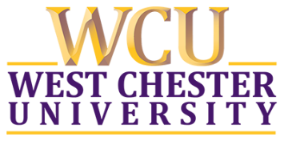
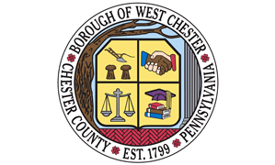

WEST CHESTER COMMUNITY CAMPUS COMMITTEE
Meeting Agenda
April 10, 2025 – 6PM
Borough Council Chambers

MISSION
The mission of the West Chester Community Campus Committee (WCCCC) is to promote and increase communication and collaboration between Borough of West Chester community leaders and residents and West Chester University officials and students on issues that affect health, safety, and quality of life for the campus and Borough community.

GUIDING PRINCIPLES
- Neighbor as a moral concept not a geographic term
- Open-mindedness and inclusion of a diversity of stakeholders and perspectives
- Respectful communication, innovative thinking, collaborative problem solving, and an equitable approach to address community need
- Collective decision making and action to the betterment of our shared community

AGENDA ITEMS
- Introductions Based Upon Any New Participants

- Public comment regarding items not on the agenda

- Approval of Meeting Minutes to Date

- Borough and University Updates
- WCU and Borough-specific new leadership cohort

- Priority Projects
- This meeting will continue to focus upon review and discussion of the Community
Campus Committee ordinance toward any potential revision(s), specifically with a
starting point of WCU membership
- Community engagement subcommittee – survey for collective event determination
- Unclaimed bikes subcommittee – survey update by Nicole, Kane, and Caleb
- Clean-up subcommittee - confirmed community-wide event date, April 27th,
12/12:30PM start time

- Other
- Second Story Collective housing model

